Skill: Literacy (optional trial)

4 - Advanced | 3 - Proficient | 2 - Partially Proficient | 1 - Developing
In addition to proficiency, I can connect and synthesize ideas within an unfamiliar context. | I can accurately obtain, and communicate historical information using all success criteria.  - Accurately applies ELO content | I can obtain and communicate historical information using some of the success criteria. | I attempt to obtain and communicate historical information.
ELO Specific Content: I can summarize the key elements of Christianity.

Success Criteria  (*all are needed to achieve proficiency) | Feedback
Obtain  - / -- | - I am able to talk to the text  - Underline words I don’t understand  - Create questions about the information in the reading as you are reading (one per paragraph)  - Multiple sentence summaries for each paragraph or section
Communicate  - / -- | - I am able to create a clear, concise and accurate summary of the reading  - Could be one summary or multiple small summaries.  - Could be notes  - Oral response

Islam: Origins and Development Islam emerged in the Middle East in the 600s C.E., centuries after Judaism and Christianity. It grew rapidly, however, and soon became one of the world's major religions.
Islam was taught by Muhammad, who was born in Mecca, in Arabia, in around 570 C.E. At the time, Mecca was an important trade center and pilgrimage site. A shrine in the heart of Mecca, called the Ka'bah, was filled with statues of local gods and spirits.
Muhammad became a successful and respected merchant. As the years passed, however, he was increasingly drawn to spiritual matters. One day in about 610 C.E., according to Islamic teachings, Muhammad was meditating in a cave when an angel appeared before him and revealed the word of Allah, or God. The angel told him he had been chosen as Allah's prophet, or messenger.
Around 613 C.E., Muhammad began to preach in Mecca. He called on Arabs to worship the one, true God. In Arabic, the word Islam means “to submit.” Muhammad's followers became known as Muslims, meaning “those who submit to God.”

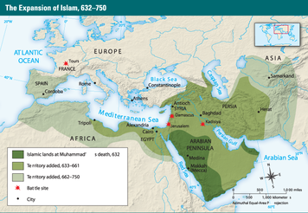
Many local leaders saw Islam as a threat to their power and prestige, however, and began to persecute the Muslims. In 622, Muhammad and his followers left Mecca and traveled to the city of Medina. There, his teachings continued to gain a following among the Arab tribes. By 630, the Muslims were strong enough to retake Mecca and establish Islam as the dominant faith of Arabia. They destroyed the statues of gods in the Ka'bah and turned it into a holy shrine of Islam.
Muhammad died in 632. But the Muslim leaders who followed continued to win converts and expand the religion. By 750, Islam had moved beyond Arabia to become the main religion of the Middle East and North Africa. It also spread to Spain, Central Asia, and India.

Summary:

The Beliefs of Islam Muslims recognize the Jewish and Christian prophets, including Abraham, Moses, and Jesus. But they regard Muhammad as the last and greatest prophet who revealed the complete message of God. They believe that the Qur'an, the Muslim holy book, contains the word of God as revealed to Muhammad.
Muslims also revere the Sunnah, the example Muhammad set for how Muslims should live. The Sunnah is recorded in a collection of stories called Hadith, which describe Muhammad's actions and teachings.
The required acts of worship for Muslims are called the Five Pillars of Islam. The first pillar is the profession of faith: “There is no god but God and Muhammad is his prophet.” This pillar emphasizes the duty Muslims have to worship one God only.

The second pillar is daily prayer. Muslims are expected to pray five times a day: at dawn, noon, mid-afternoon, sunset, and after nightfall. They kneel before God and recite verses from the Qur'an. Prayer does not have to take place at a mosque, or place of worship, but can be performed anywhere.
The third pillar is charity. Muhammad told the wealthy to share their riches with the less fortunate. Muslims are supposed to give at least 2.5 percent of their surplus wealth every year to the needy. The Qur'an says: “You will never attain righteousness until you give freely of what you love.”
The fourth pillar is fasting. The Qur'an instructs Muslims to abstain from food or drink during daylight hours for the entire month of Ramadan, the ninth month of the Muslim calendar. Fasting is meant to encourage self-control and clear the mind so that it can be filled with the spirit of faith.
The fifth pillar is the pilgrimage to Mecca, known as the Hajj, which takes place in the twelfth month of the year. This pilgrimage promotes fellowship and equality among believers. The Hajj is not required, but all Muslims are encouraged to undertake it at least once in their lifetime.
Summary:

The Spread and Influence of Islam Islam continued to extend its influence over the next several centuries. It spread east across South Asia to the islands of Indonesia. It moved north into Turkey and the Balkans region of Europe. It also expanded rapidly along the east coast of Africa and into the African interior, south of the Sahara.
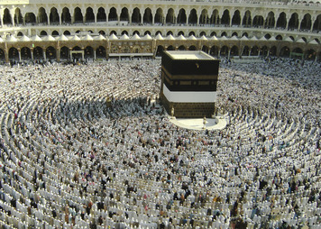
Islam was a missionary religion, seeking to win converts, particularly in areas where polytheism prevailed. Muslims sometimes waged “holy war,” clashing with followers of other religions, including Christians. But they also respected Christians and Jews as people of faith and often lived alongside them in peace.
Today, with over a billion followers, Islam is the second largest religion in the world. More than a religion, however, it is a way of life. In Muslim lands, Islam has had a profound impact on culture, society, and politics. Shari'ah, Islamic law based on the Qur'an and Sunnah, provides guidance on all aspects of life, from clothing and food to education and finance. Shari'ah also forms the basis of legal codes in many Muslim countries.

Summary:

